**1.**

Question 1

"What will be the output of the following code?

1

2

3

4

import re

string = 'bat, lat, mat, bet, let, met, bit, lit, mit, bot, lot, mot'

result = re.findall('b[ao]t', string)

print(result)

1 / 1 point

['bat', 'bet', 'bit', 'bot']

'bat, bet, bit, bot'

['bat', 'bot']

'bat, bot'

Correct

[au] means any character from 'a' and 'o' (or both) hence only 'bat' and 'bot' would be extracted

**2.**

Question 2

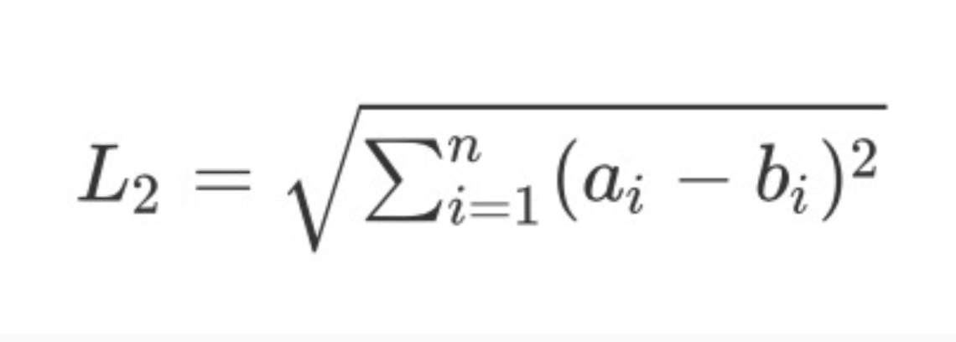

Assume **a** and **b** are two (20, 20) numpy arrays. The L2-distance (defined above) between two equal dimension arrays can be calculated in python as follows:

1

2

3

4

def l2_dist(a, b):

    result = ((a - b) * (a - b)).sum()

    result = result ** 0.5

    return result

Which of the following expressions using this function will **produce a different result from the rest**?

1 / 1 point

l2_dist(a.T, b.T)

l2_dist(a, b)

l2_dist(np.reshape(a, (20 * 20)), np.reshape(b, (20 * 20, 1)))

l2_dist(np.reshape(a, (20 * 20)), np.reshape(b, (20 * 20)))

Correct

The ndim of the two inputs in D are different.

**3.**

Question 3

Consider the following variables in Python:

1

2

3

4

5

a1 = np.random.rand(4)

a2 = np.random.rand(4, 1)

a3 = np.array([[1, 2, 3, 4]])

a4 = np.arange(1, 4, 1)

a5 = np.linspace(1 ,4, 4)

Which of the following statements regarding these variables is correct?

1 / 1 point

a4.ndim() == 1

a3.shape == a4.shape

a1.shape == a2.shape

a5.shape == a1.shape

Correct

This is a correct expression because the two arrays have the same shape.

**4.**

Question 4

Which of the following is the correct output for the code given below?

1

2

3

4

5

6

7

import numpy as np

old = np.array([[1, 1, 1], [1, 1, 1]])

new = old

new[0, :2] = 0

print(old)

1 / 1 point

[[0 1 1][0 1 1]]

[[1 1 1][1 1 1]]

[[0 0 1][1 1 1]]

[[1 1 0][1 1 0]]

Correct

Array slices are passed by reference; After the statement 'new=old', any changes made to 'new' will carry over to 'old', so 'old' will not remain unchanged

**5.**

Question 5

Given the 6x6 NumPy array **r** shown below, which of the following options would slice the shaded elements?

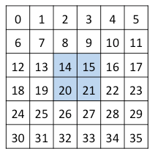

1 / 1 point

r[2:4,2:4]

r[2:3,2:3]

r[[2,3],[2,3]]

r[[2,4],[2,4]]

Correct

Array indices start with 0 and an array slice from m:n includes elements from indices m to n-1.

**6.**

Question 6

1

2

import re

s = 'ACBCAC'

For the given string, which of the following regular expressions can be used to check if the string starts with 'AC'?

1 / 1 point

re.findall('^[AC]', s)

re.findall('AC', s)

re.findall('[^A]C', s)

re.findall('^AC', s)

Correct

Here, the caret ^ denotes the beginning of the string, and hence will extract the first 'AC' from the string s.

**7.**

Question 7

What will be the output of the variable **L** after the following code is executed?

1

2

3

4

import re

s = 'ACAABAACAAAB'

result = re.findall('A{1,2}', s)

L = len(result)

1 / 1 point

4

12

8

5

Correct

The pattern we are using is a single A or a double A, hence we will find the results as (A)C(AA)B(AA)C(AA)(A)B.

**8.**

Question 8

Which of the following is the correct regular expression to extract all the phone numbers from the following chunk of text:

1

2

3

4

5

6

Office of Research Administration: (734) 647-6333 | 4325 North Quad

Office of Budget and Financial Administration: (734) 647-8044 | 309 Maynard, Suite 205

Health Informatics Program: (734) 763-2285 | 333 Maynard, Suite 500

Office of the Dean: (734) 647-3576 | 4322 North Quad

UMSI Engagement Center: (734) 763-1251 | 777 North University

Faculty Adminstrative Support Staff: (734) 764-9376 | 4322 North Quad

1 / 1 point

[(]\d{3}[)]\d{3}[-]\d{4}

[(]\d{3}[)]\s\d{3}[-]\d{4}

\d{3}[-]\d{3}[-]\d{4}

\d{3}\s\d{3}[-]\d{4}

Correct

The symbols '(', ')', and '-' that need to be extracted are properly separated by brackets and present (they aren't in other options). Also, the space character '\s' is present in the right places to match the pattern.

**9.**

Question 9

Which of the following regular expressions can be used to get the domain names (e.g. google.com, www.baidu.com) from the following sentence?

1

'I refer to https://google.com and I never refer http://www.baidu.com if I have to search anything'

1 / 1 point

(?<=https:\/\/)([.]*)

(?<=[https]:\/\/)([A-Za-z0-9.]*)

(?<=https:\/\/)([A-Za-z0-9]*)

(?<=https:\/\/)([A-Za-z0-9.]*)

Correct

Bracketing the [https] means we are looking for any and as many of those letters. Since the second web link begins with 'http' not 'https', 'https' should be surrounded by square brackets. Also, in 'A-Za-z0-9.', the '.' is required.

**10.**

Question 10

The text from the Canadian Charter of Rights and Freedoms section 2 lists the fundamental freedoms afforded to everyone. Of the four choices provided to replace **X** in the code below, which would accurately count the number of fundamental freedoms that Canadians have?

1

2

3

4

5

6

7

8

9

text=r'''Everyone has the following fundamental freedoms:

    (a) freedom of conscience and religion;

    (b) freedom of thought, belief, opinion and expression, including freedom of the press and other media of communication;

    (c) freedom of peaceful assembly; and

    (d) freedom of association.'''

import re

pattern = X

print(len(re.findall(pattern,text)))

1 / 1 point

1

'freedom'

1

'[a-d]'

1

(.)

1

\(.\)

Correct

This code will find any character that is not a linebreak that is within parenthesis, hence counting (a), (b), (c), and (d) which is same as counting the 4 fundamental freedoms